* **Title Page: cs 1011-051 – Lab 5 <*Growth Rate*>**
* <Denise Malisa>
* <12/10/2020>
* <Page Break>
* **I. Objectives**

The purpose of this program is to generate a game that the user will play based on a situation where there is an option for exponential growth and another for linear growth. Both options will result in a monetary value, the user is supposed to choose the option that returns the greatest value.

For one option the user starts out with an amount that is randomly generated (the linear option) and the other a small fixed amount is a fixed start amount (exponential option). The user does not know the randomly generated start amount.

* **II. Requirements**

The program is supposed to ask the user which option they want.

Then the program will display the amount the user earns and each

week for both options, depending on the user’s choice the program will determine whether the user has lost or won if when the program stops either due to the economic crises happening or the exponential value is greater than the linear and the option chosen by the user has the greater return on investment. The program generates a random number (deposit) for the starting amount of the linear calculation which is the amount the user would deposit into a bank that returns interest at a fixed rate each week. Then it will also generate a random number for the week the economic crises occur. My program uses multiple loops as well as the Math.random() method and the Math.abs ().

* **III. Design:**

Get user input

Output game brief

Repeat

Output: choose option

Get user option

Repeat

Calculate linear and exponent

Generate if statements to check the conditions for when the user has won or when they have lost

Generate differences between linear and exponent

If they have one display output message

If they lost display output method

Ask if user wants to play again

Then repeat the process.

* **III. Test Plan/Test Strategy**

I will test the game firstly by checking that if user chooses option 1 they get the values they are supposed and the correct message of whether they have own or lost. The same will be checked for option 2.

* **IV. Results**

The program satisfies all tests

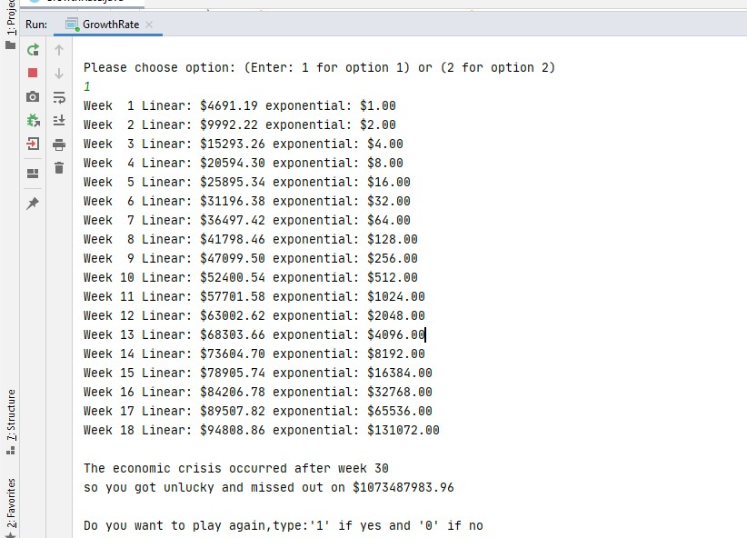

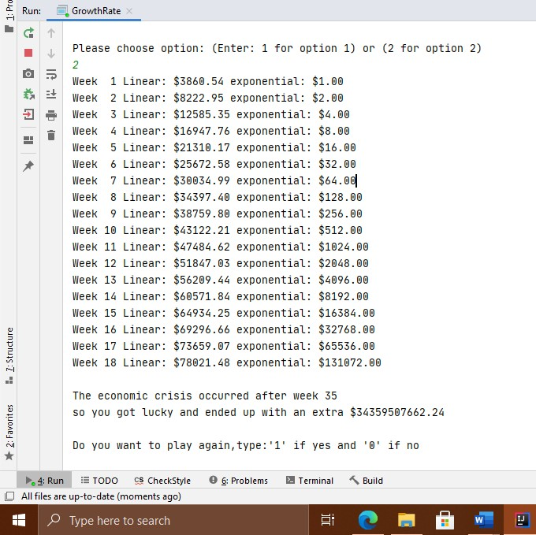

**V. Discussion**

I have a deeper understanding of loops, I also learnt how to format decimals using a different method than using the one I have used previously.